**Udemy:  
Video1:**

AWS first came into market in 2006. Initially AWS aimed at startups who doesn’t have much budget invest and also who want experiment with cloud but now everyone from in-house developer to a Fortune 500 company using it.

AWS certifications were launched in 2013.

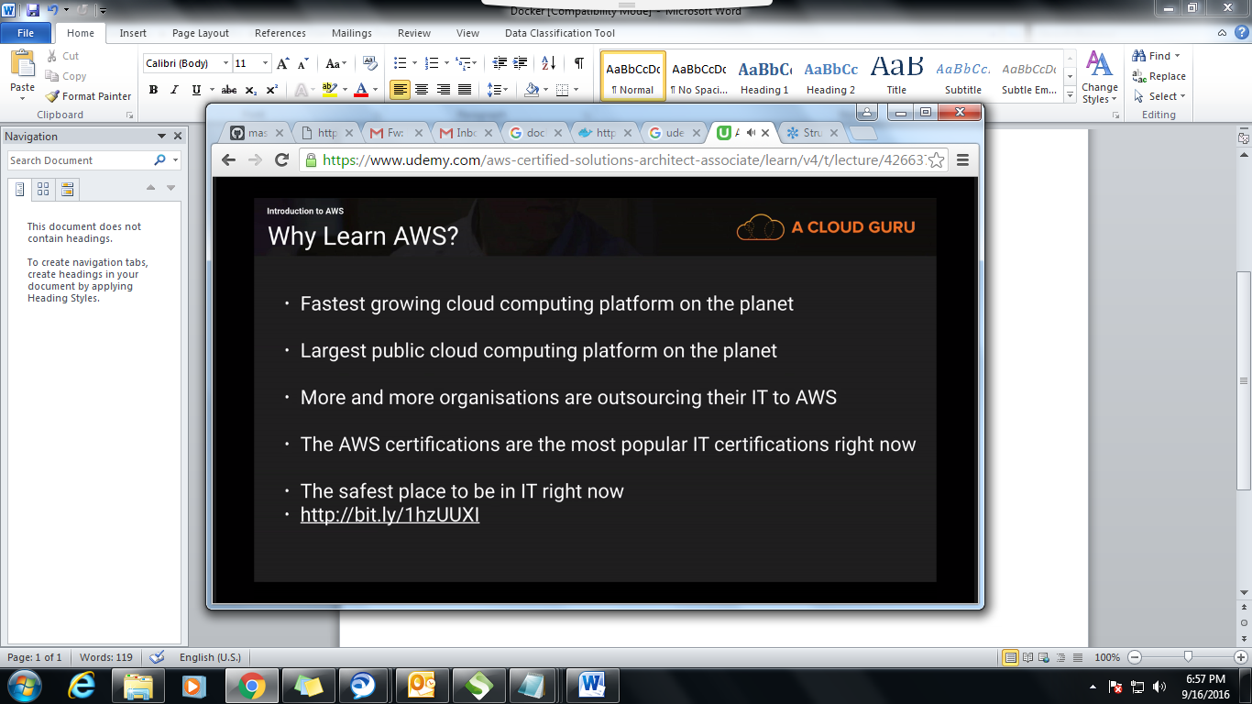

First you need to done with the Associate Tier and then move onto Professional Tier. If you want to be a “DevOps” professional then you don’t have to complete 2 courses below that one. Any one of them is enough.

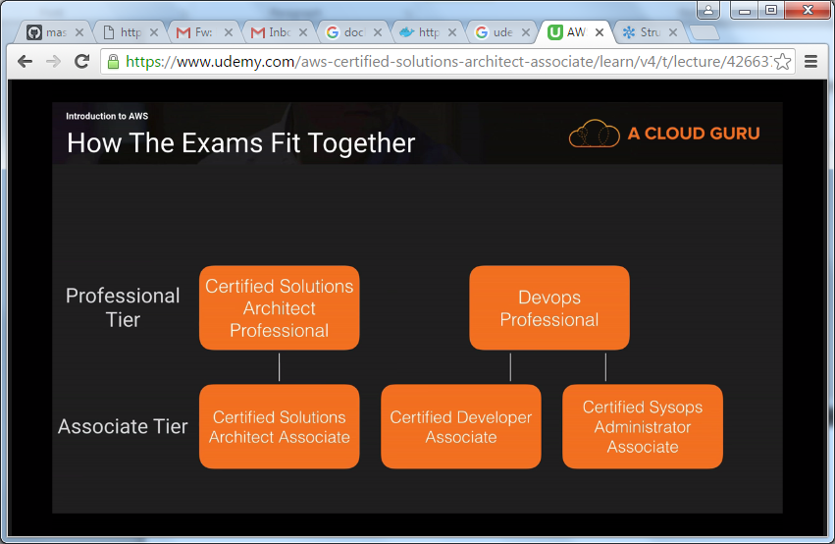

This course is for Solutions Architect Associate. But if you clear this exam then you can easily clear the Developer Associate. You don’t need to be a developer to write the Developer Associate.

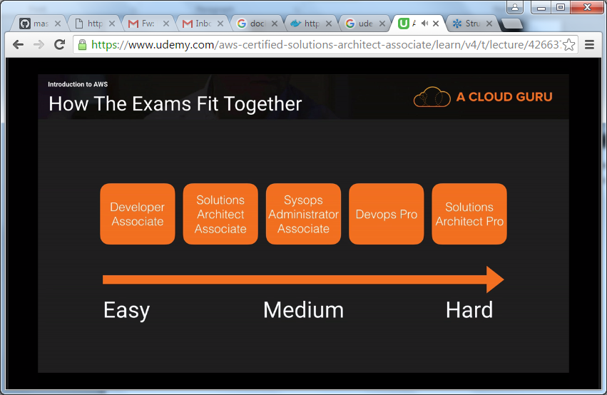

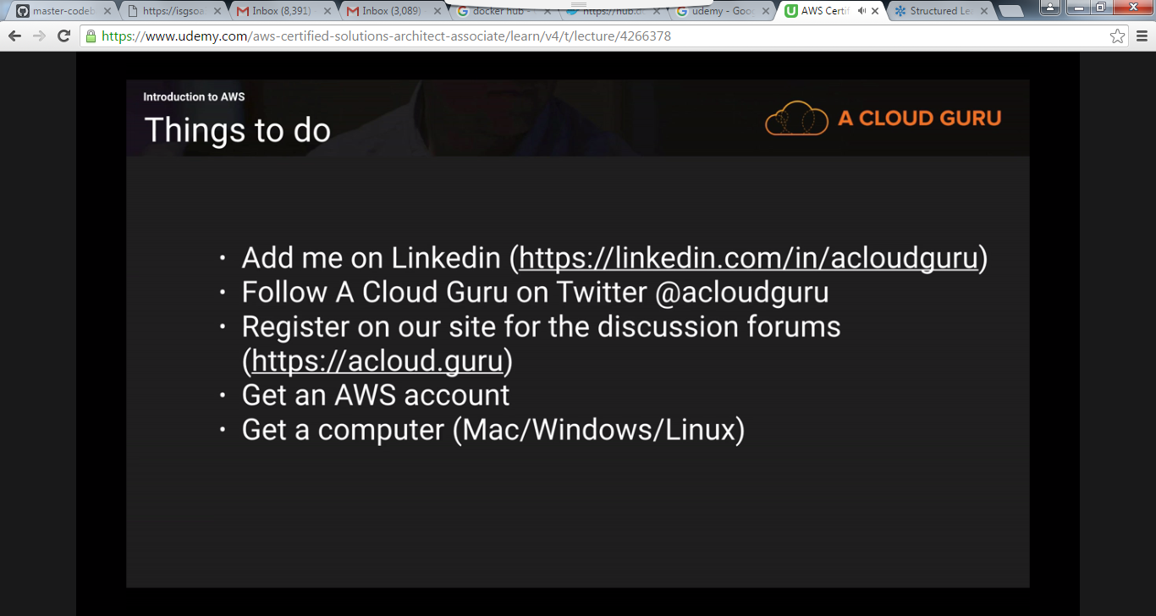

Video2:

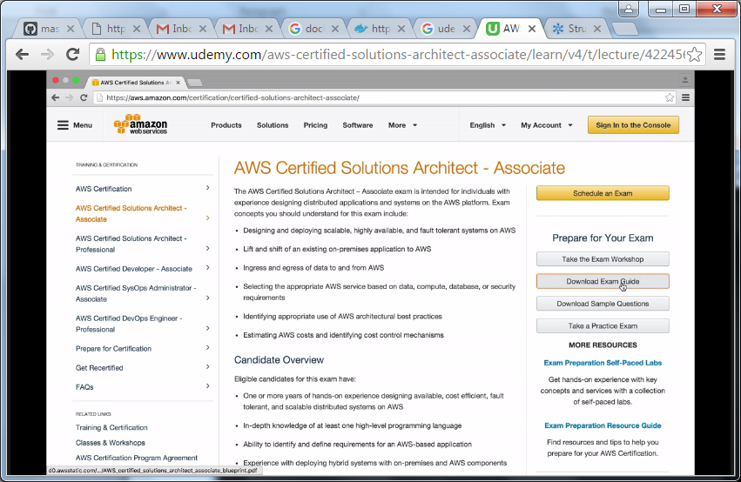

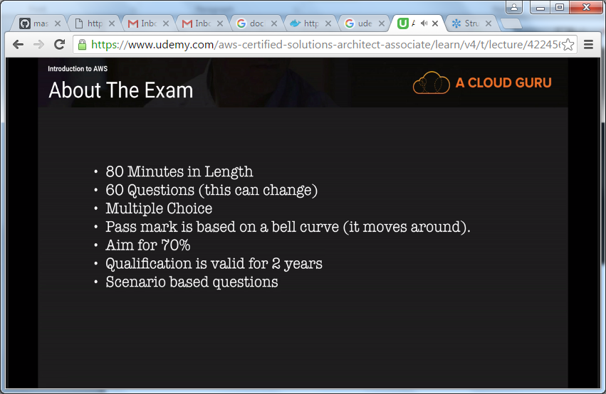

Video3:

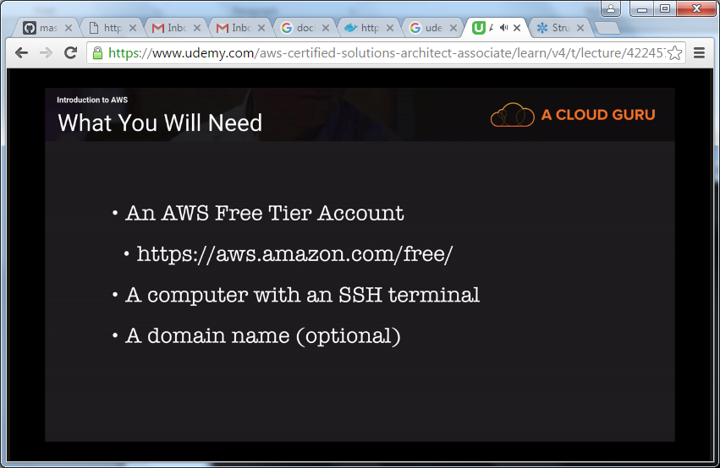

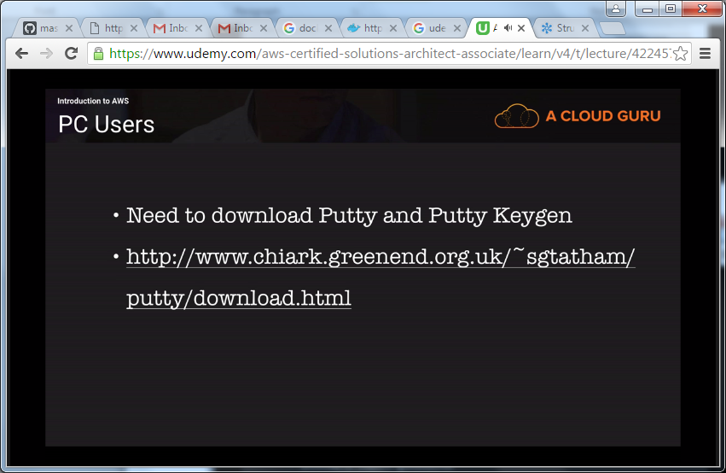

Video4:   
Alexa Skill: It is a device which asks you questions.

Video5:  
 This App costs 20 dollars. Here you can find different questions. 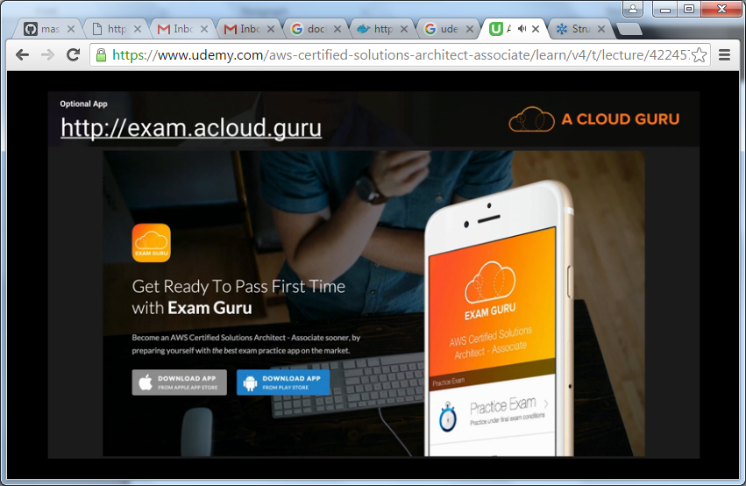

Video6:  
With AWS, there is no long time contracts and you will only pay for what you use.  
jeff barr

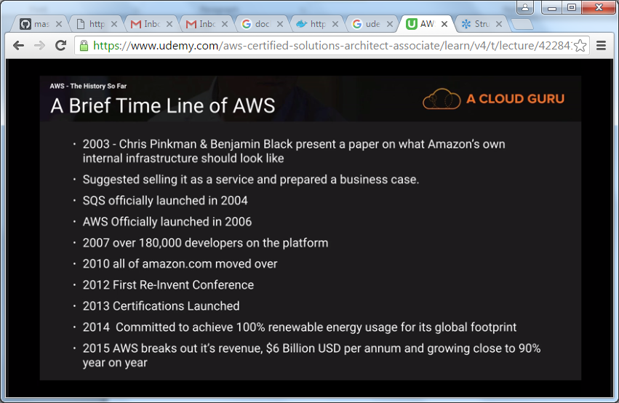

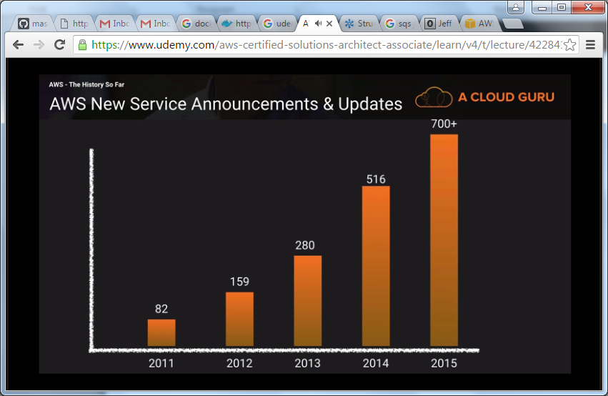

AWS (90%) is the leader in cloud followed by Microsoft (5%) and Rackspace etc.

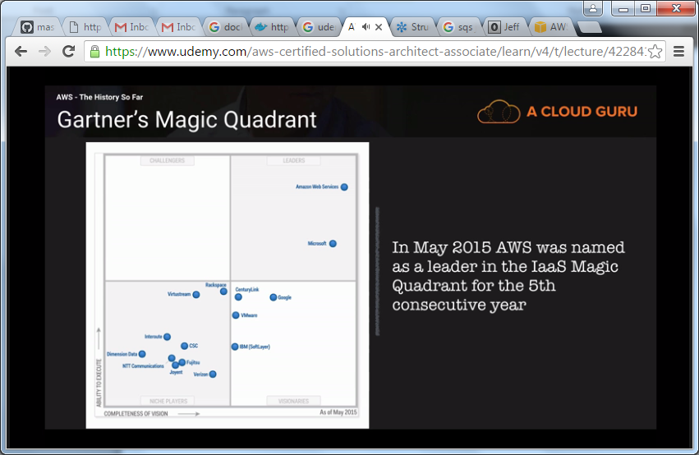

**Video7:**

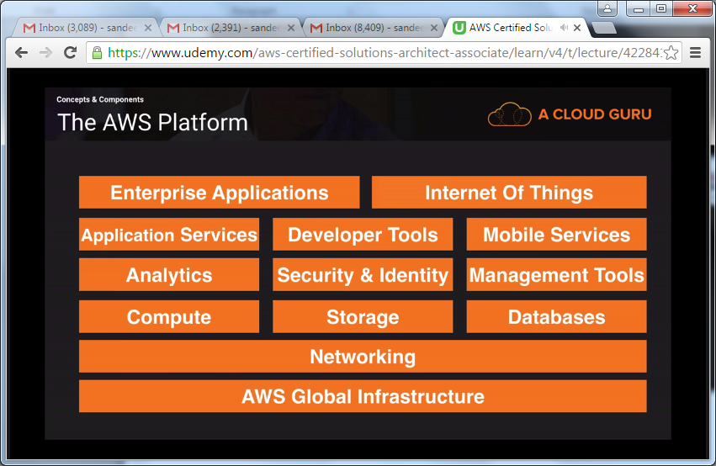  
The only region which is missing here is Africa.

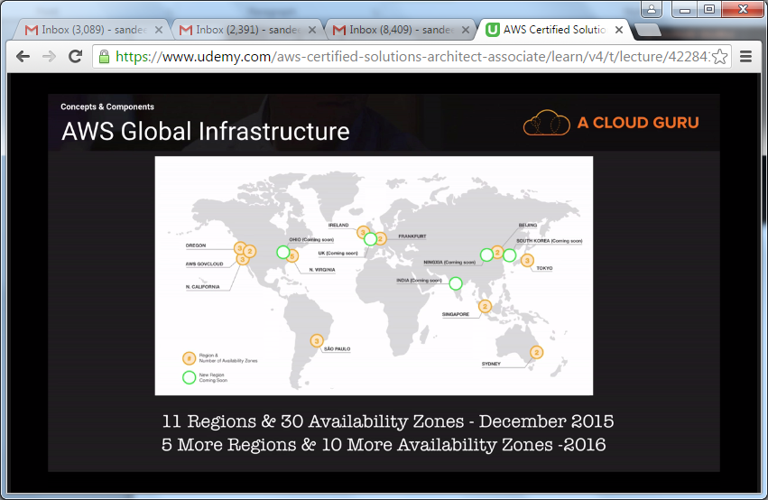

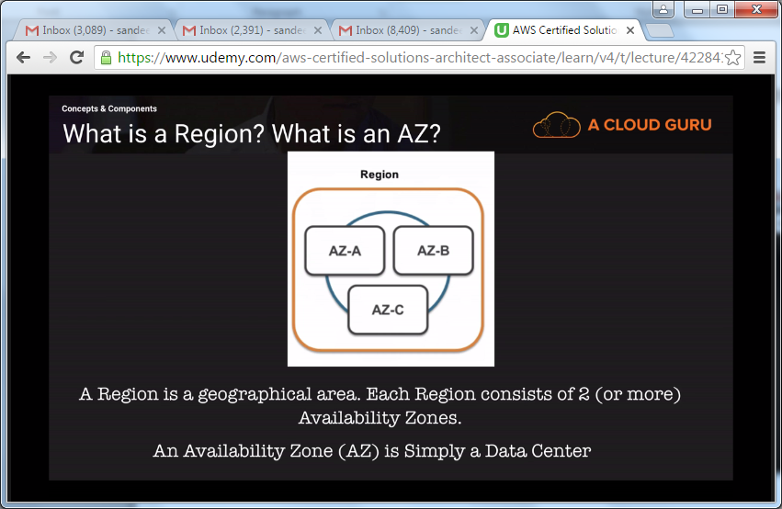

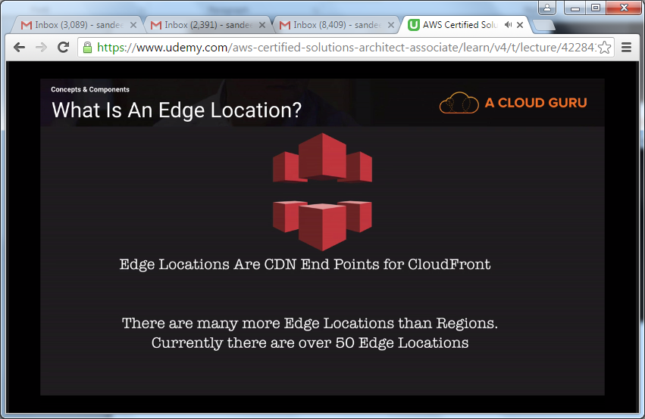

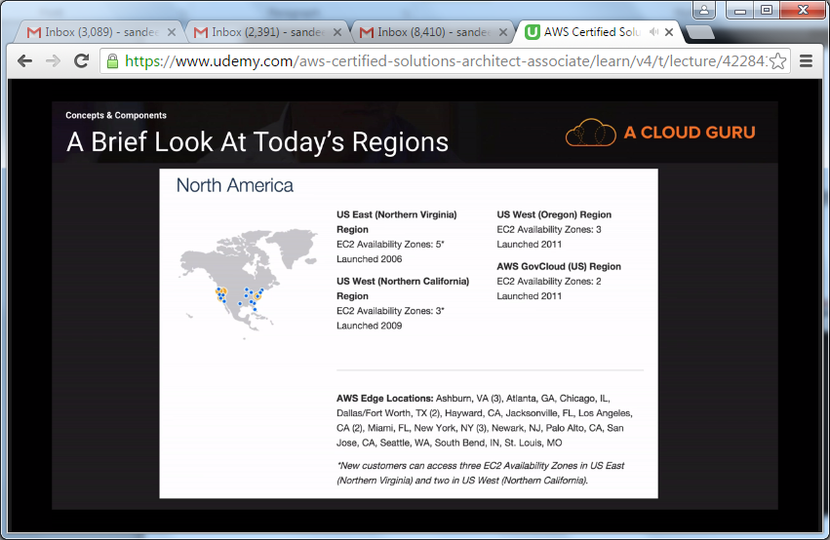

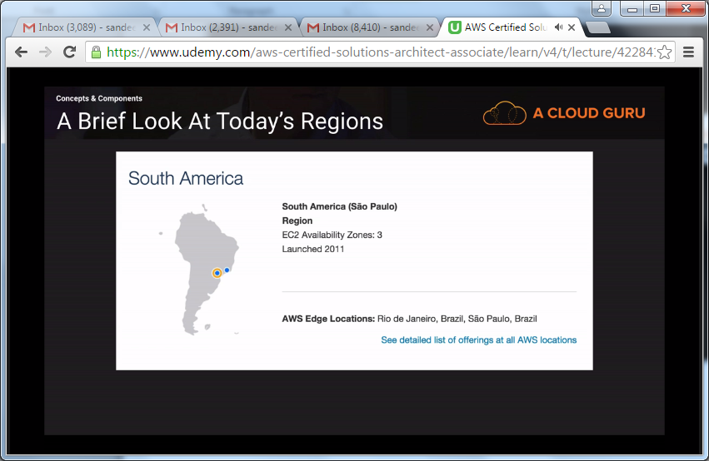

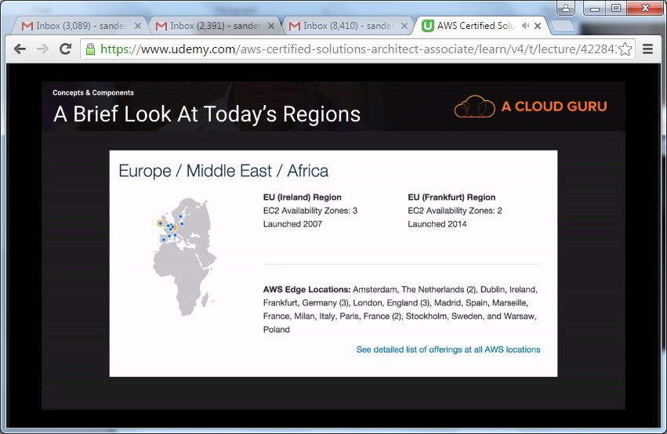

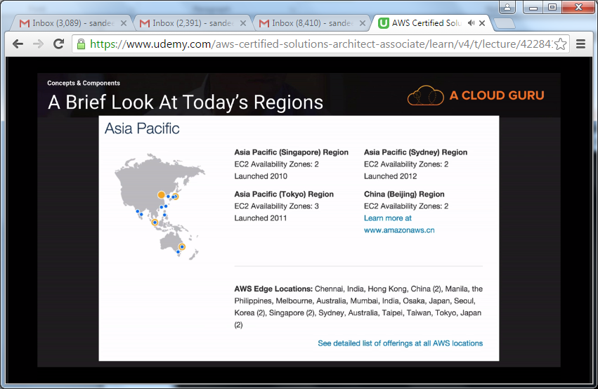

Think of VPC (Virtual Private Cloud) as a virtual data center. We can have multiple VPC’s in our aws account.

Without using internet we can connect to AWS environment using direct connect.

Route 53 (Route 66) is amazon’s DNS service. DNS service sits on port no 53.

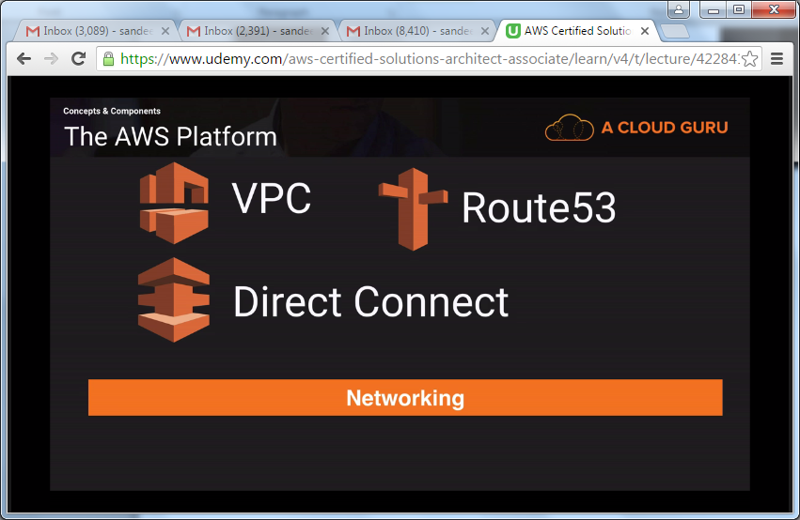

Note: The great thing about lambda is you only pay for the compute time you use.

AWS **Lambda** is a compute service where you can upload your code to AWS Lambda and the service can run the code on your behalf using AWS infrastructure. After you upload your code and create what we call a *Lambda function*, AWS Lambda takes care of provisioning and managing the servers that you use to run the code. You can use AWS Lambda as follows:

* As an event-driven compute service where AWS Lambda runs your code in response to events, such as changes to data in an Amazon S3 bucket or an Amazon Dynamo DB table.
* As a compute service to run your code in response to HTTP requests using Amazon API Gateway or API calls made using AWS SDKs.

AWS Lambda runs your code on a high-availability compute infrastructure and performs all of the administration of the compute resources, including server and operating system maintenance, capacity provisioning and automatic scaling, code monitoring and logging. All you need to do is supply your code in one of the languages that AWS Lambda supports (currently Node.js, Java, and Python).

AWS Lambda executes your code only when needed and scales automatically, from a few requests per day to thousands per second. With these capabilities, you can use Lambda to easily build data processing triggers for AWS services like Amazon S3 and Amazon DynamoDB, process streaming data stored in Amazon Kinesis, or create your own back end that operates at AWS scale, performance, and security.

When Should I Use AWS Lambda?

AWS Lambda is an ideal compute platform for many application scenarios, provided that you can write your application code in languages supported by AWS Lambda (that is, Node.js, Java, and Python), and run within the AWS Lambda standard runtime environment and resources provided by Lambda.

When using AWS Lambda, you are responsible only for your code. AWS Lambda manages the compute fleet that offers a balance of memory, CPU, network, and other resources. This is in exchange for flexibility, which means you cannot log in to compute instances, or customize the operating system or language runtime. These constraints enable AWS Lambda to perform operational and administrative activities on your behalf, including provisioning capacity, monitoring fleet health, applying security patches, deploying your code, and monitoring and logging your Lambda functions.

If you need to manage your own compute resources, Amazon Web Services also offers other compute services to meet your needs.

* **Amazon Elastic Compute Cloud** (**Amazon EC2**) service offers flexibility and a wide range of EC2 instance types to choose from. It gives you the option to customize operating systems, network and security settings, and the entire software stack, but you are responsible for provisioning capacity, monitoring fleet health and performance, and using Availability Zones for fault tolerance.
* **Elastic Beanstalk** offers an easy-to-use service for deploying and scaling applications onto Amazon EC2 in which you retain ownership and full control over the underlying EC2 instances.

**EC2 Container Server (Amazon ECS)** is a highly scalable and fast container management service which makes it easy to Run, stop and manage Docker containers on a cluster of amazon EC2 instances.

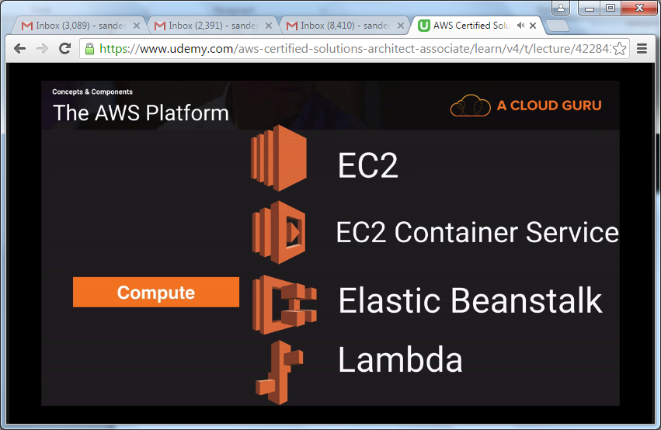

Video8:

**S3** is a place to store your flat files in the cloud. S3 is secure, durable and highly scalable.  
**Cloud Front** integrates with S3. Edge location is a place that caches your files.  
Amazon **Glacier** is an extremely low-cost storage service that provides secure, durable, and flexible storage for data backup and archival. With Amazon Glacier, customers can reliably store their data for as little as $0.007 per gigabyte per month. Amazon Glacier enables any business or organization to easily and cost effectively retains data for months, years, or decades. With Amazon Glacier, customers can now cost effectively retains more of their data for future analysis or reference, and they can focus on their business rather than operating and maintaining their storage infrastructure.

**Note:** Use Amazon S3 if you need low latency or frequent access to your data. Use Amazon Glacier if low storage cost is paramount, your data is rarely retrieved, and data retrieval times of several hours are acceptable. Amazon S3 now provides a new storage option that enables you to utilize Amazon Glacier’s extremely low-cost storage service for data archiving. You can define S3 lifeycycle rules to automatically archive sets of Amazon S3 objects to Amazon Glacier to reduce your storage costs.  
**Amazon Elastic File System (Amazon EFS)** provides simple, scalable file storage for use with Amazon EC2 instances in the AWS Cloud. Amazon EFS is easy to use and offers a simple interface that allows you to create and configure file systems quickly and easily. With Amazon EFS, storage capacity is elastic, growing and shrinking automatically as you add and remove files, so your applications have the storage they need, when they need it.  
When mounted to Amazon EC2 instances, an Amazon EFS file system provides a standard file system interface and file system access semantics, allowing you to seamlessly integrate Amazon EFS with your existing applications and tools. Multiple Amazon EC2 instances can access an Amazon EFS file system at the same time, allowing Amazon EFS to provide a common data source for workloads and applications running on more than one Amazon EC2 instance.  
It’s designed for high availability and durability, and provides performance for a broad spectrum of workloads and applications, including Big Data and analytics, media processing workflows, content management, web serving, and home directories.  
AWS Import/Export is a service that accelerates transferring large amounts of data into and out of AWS using physical storage appliances, bypassing the Internet. AWS Import/Export has two features that support this functionality in two different ways, **AWS Snowball (Snowball)** and AWS Import/Export Disk (Disk).

With Snowball, you can transfer hundreds of terabytes or petabytes of data between your on-premises data centers and Amazon Simple Storage Service (Amazon S3).   
By shipping your data in Snowballs, you can transfer large amounts of data at a significantly faster rate than if you were transferring that data over the Internet, saving you time and money.  
**Note:** There are many options for transferring your data into AWS. Snowball is intended for transferring large amounts of data. If you want to transfer less than 10 terabytes of data between your on-premises data centers and Amazon S3, Snowball might not be your most economical choice.

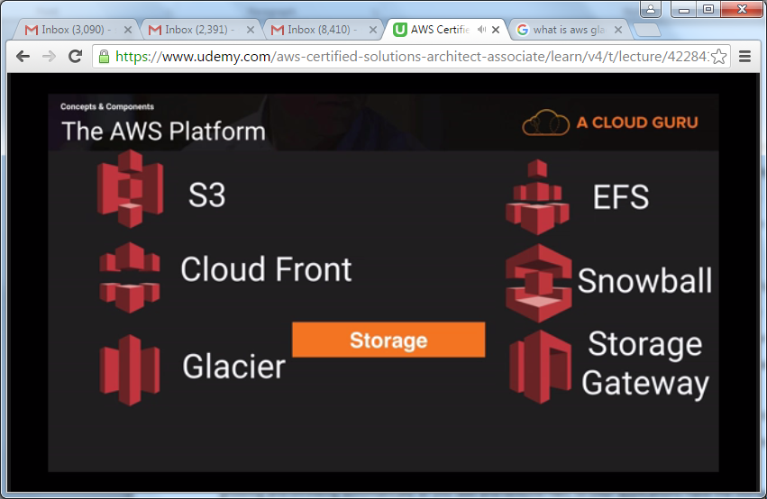

Dynamo Db is a non-relational DB.

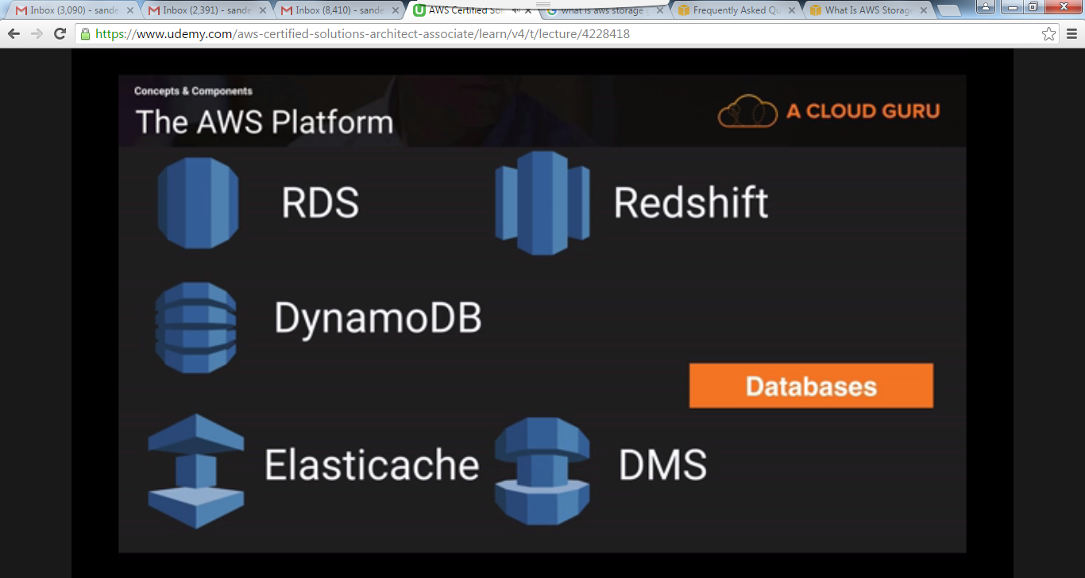

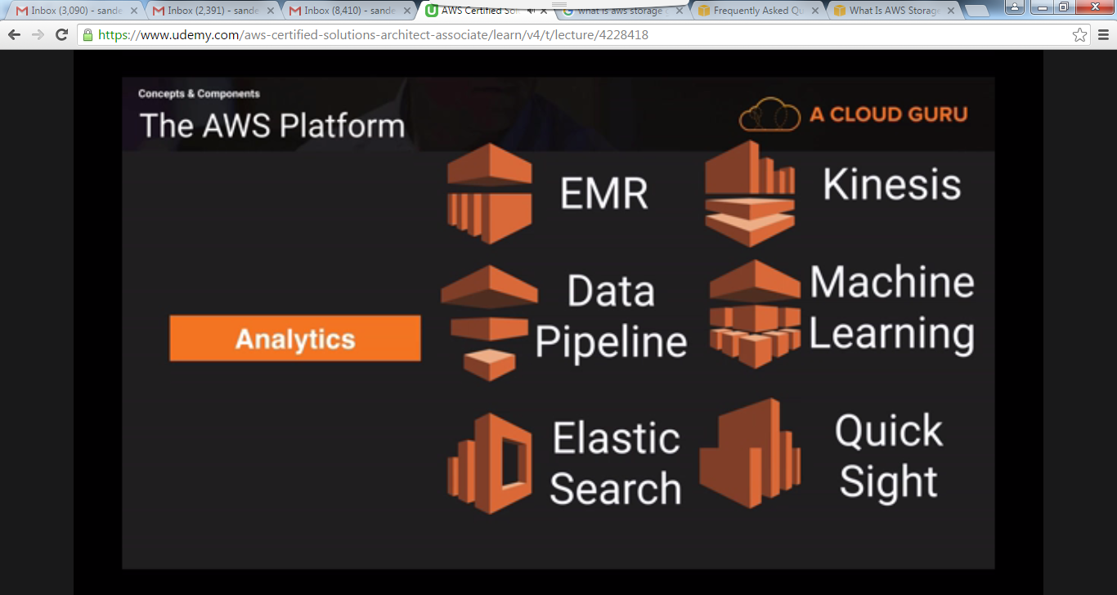

**Video9:**

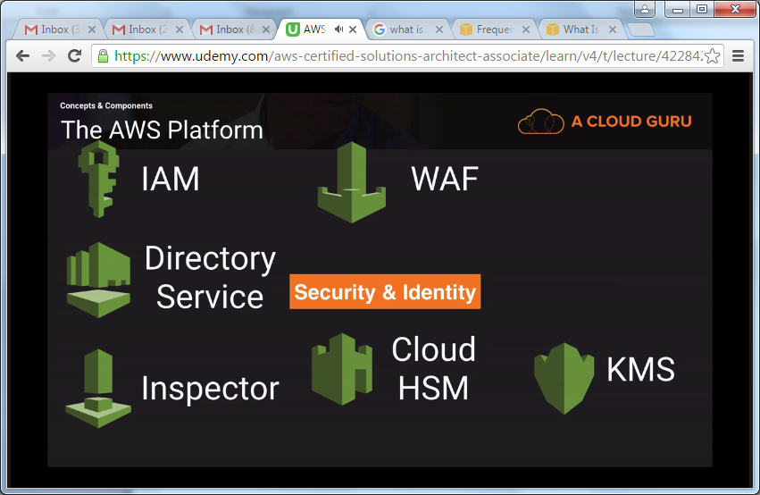

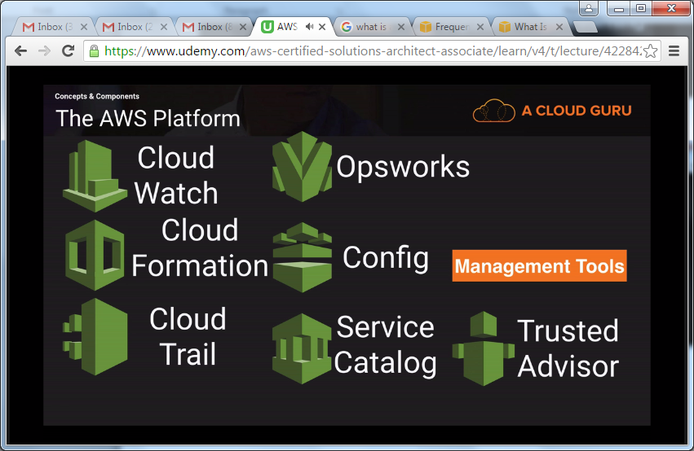

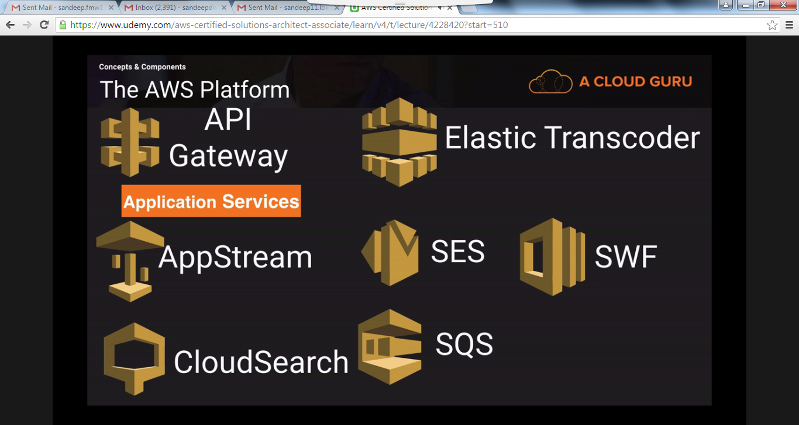

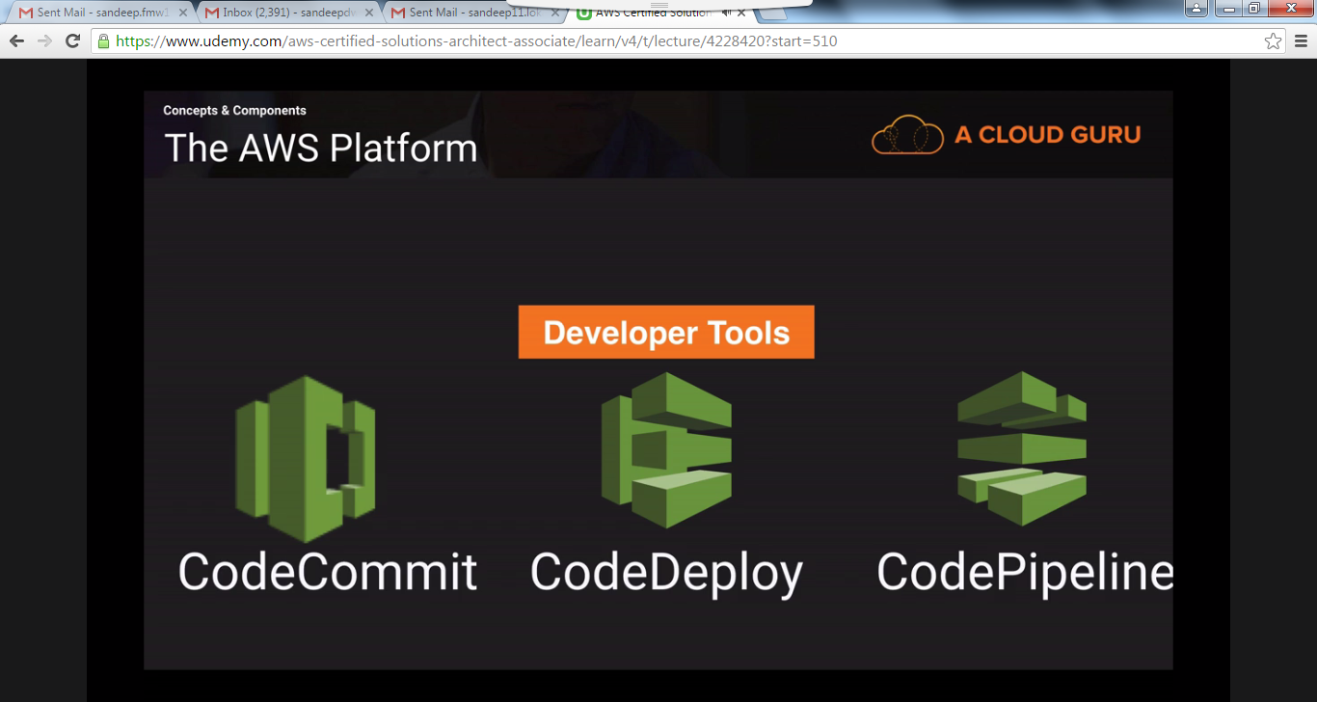

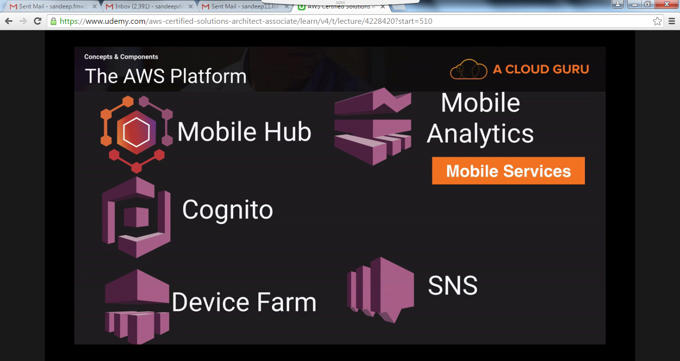

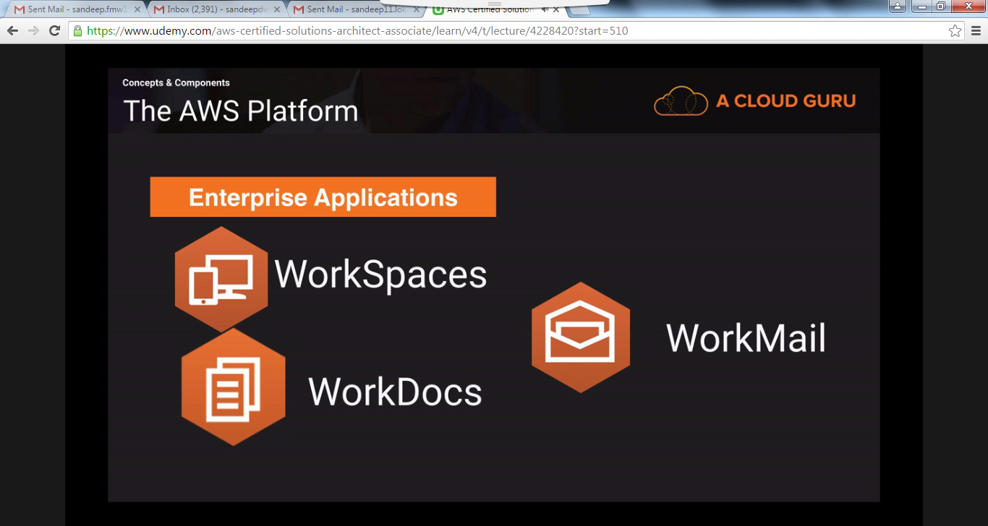

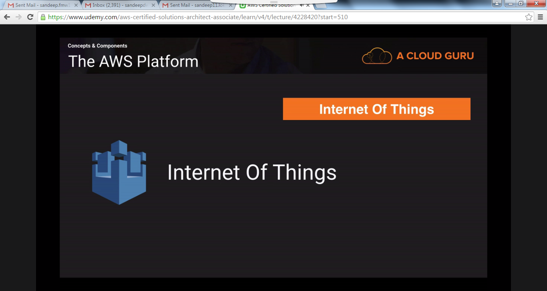

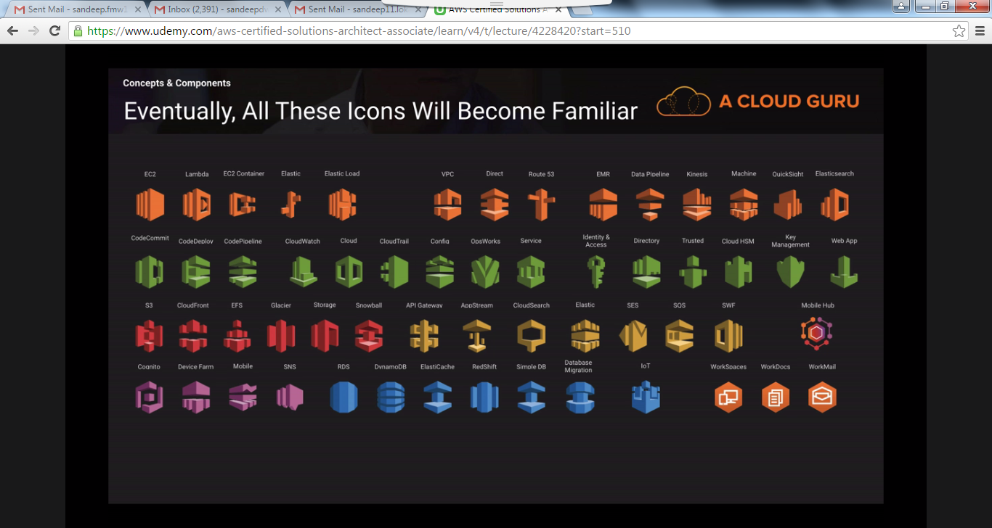

**Video10:**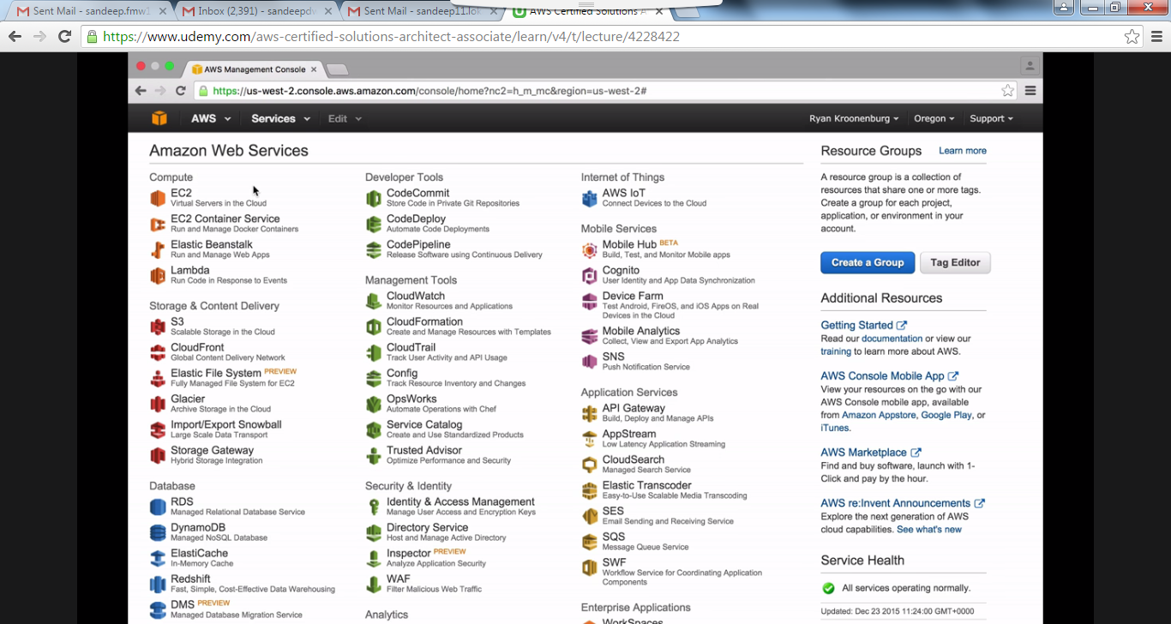

**Video11:  
Identity Access management:** It is the best topic to start with AWS.  
  
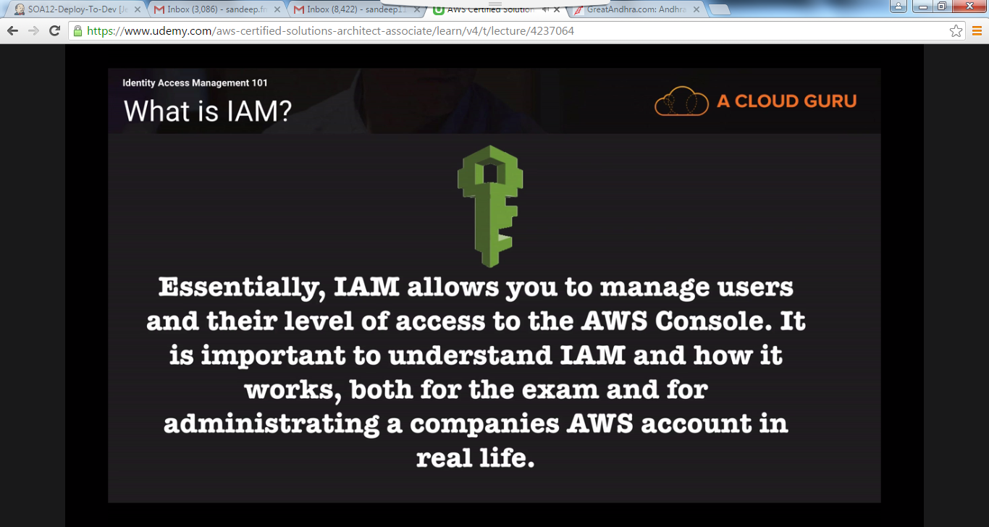

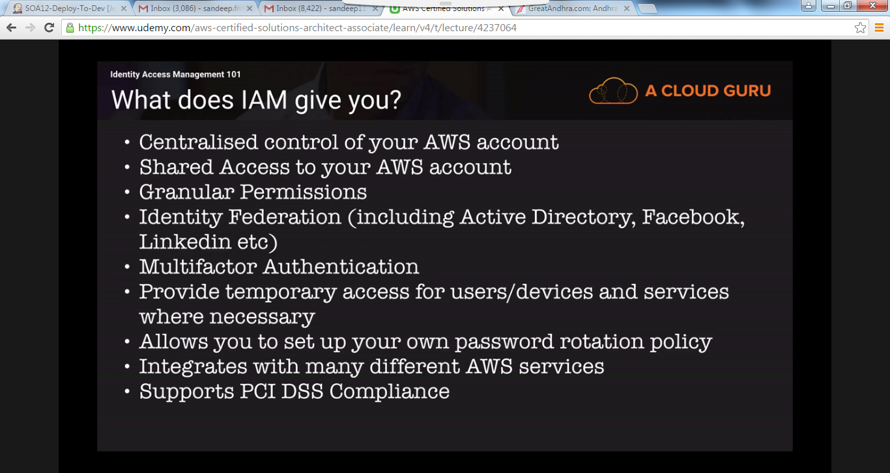

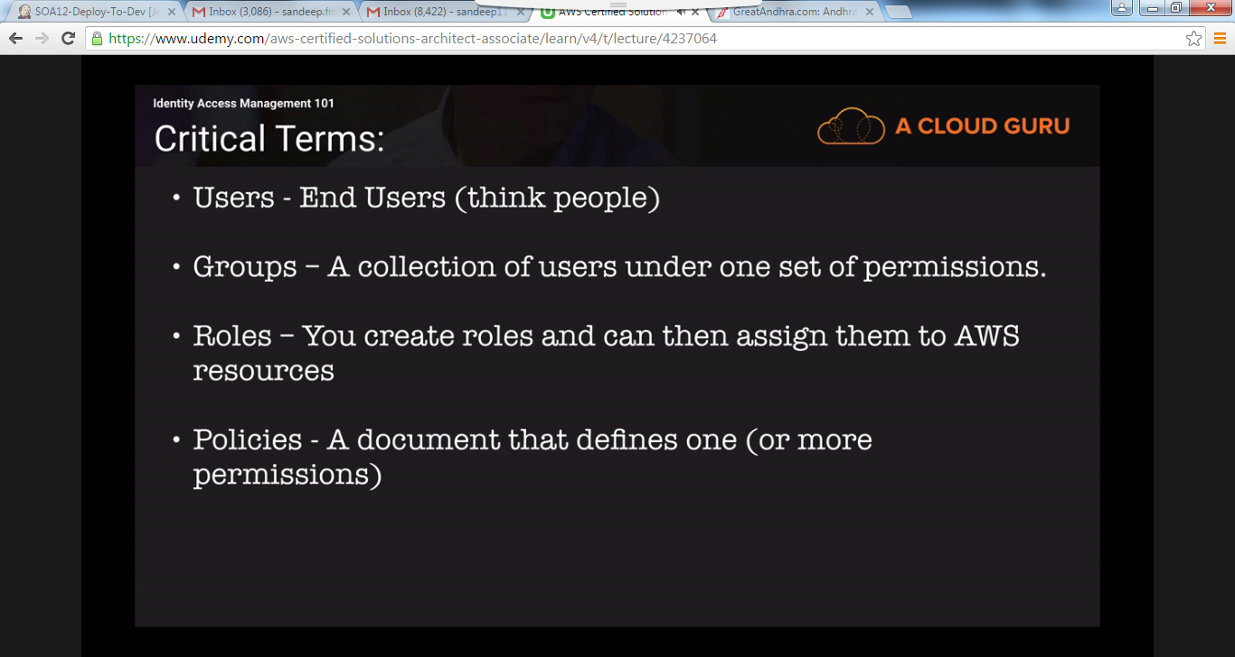

**Video12:**

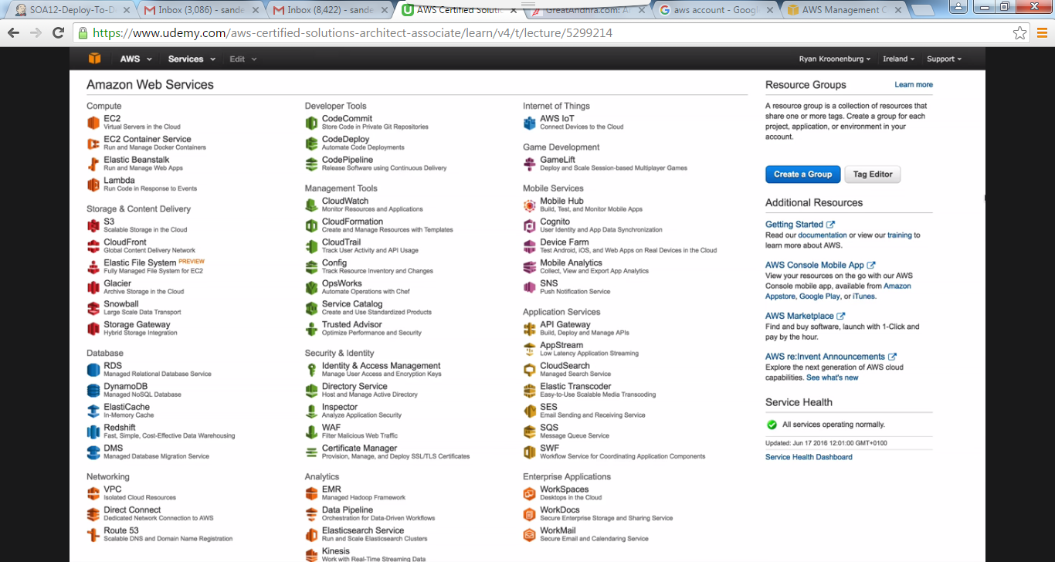Once you login to aws account, if your console is not looking like above then you can change console to   
look like the above screen by selecting the below marked option.

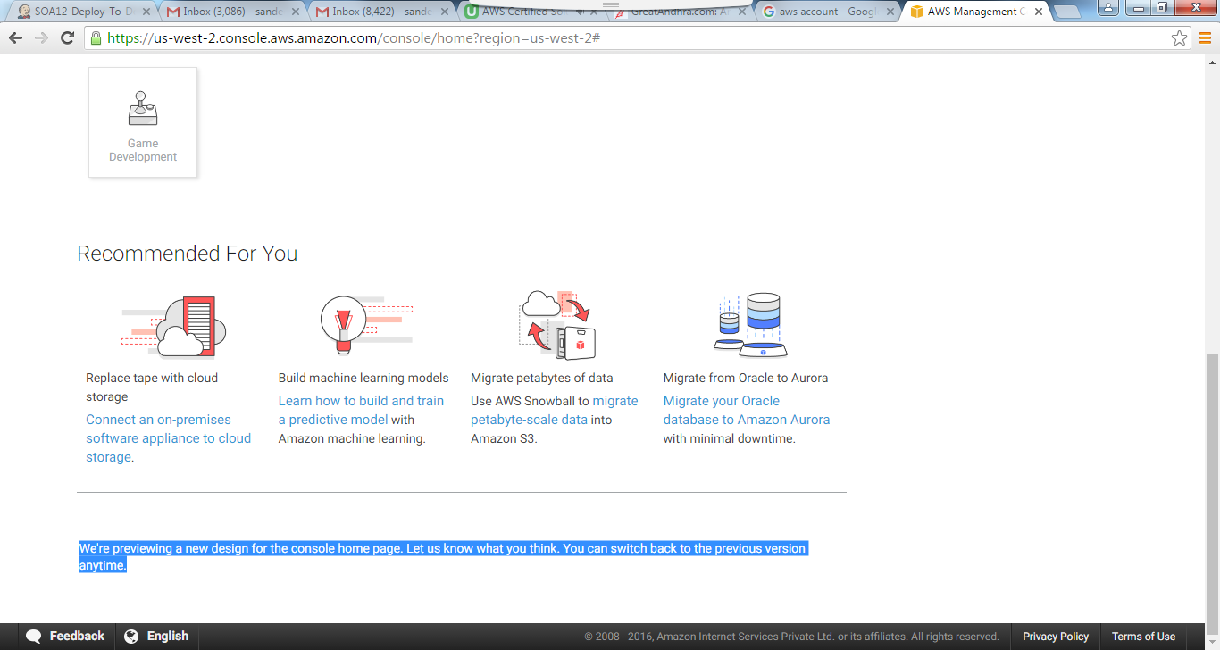

**Video13:**Whenever you login to the AWS, the default region you see is US-West-Oregon. You can change your region. It is better to select the region which is near to you.

**Note:** The users, groups, roles are not region specific. They are global.  
**Activate MFA (Multi factor Authentication)** **on your root account:** It is used to add another level of protection to your root account. You can either add a Virtual MFA (ex: Google Authenticator) or a hardware MFA (ex: RSA token).  
**Note:** Root account is the email address that you used while creating AWS account. Root account will have all the admin access.

**Create individual IAM users:** Create IAM users and give them only the permissions they need. Do not use your AWS root account for day-to-day interaction with AWS, because the root account provides unrestricted access to your AWS resources.  
When you create the users, they will be provided with Access key and secret key. You can see them only once, so it is better to download them. We use AK and SK to connect to the AWS account from command line.  
In the next window you can create a password for the user to login to the console.  
**Note:** By default the newly created user will not have any permission to do.

The newly created users can use the below link to login to the console.  
[**https://lokaerj.signin.aws.amazon.com/console**](https://lokaerj.signin.aws.amazon.com/console)

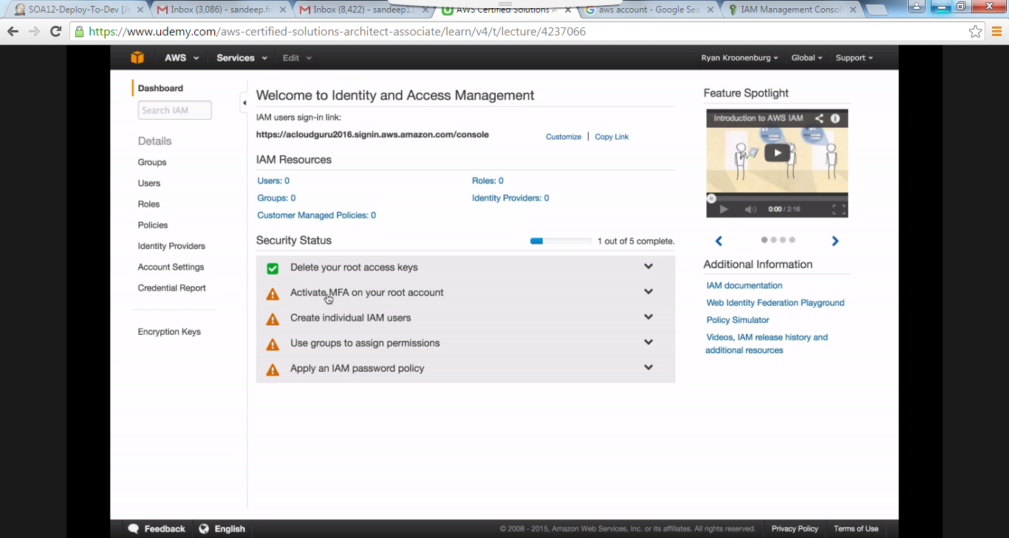

Permissions can be granted to the users using policies.  
Click on policies and there you will see lot of policies and one of them is AdministratorAccess policy. Policy document is in JSON (Java Script Object Notation) language (You can see key-value pairs in this language). Select the policy and select Attach policy and then select the user to whom you want to attach it.  
Instead of attaching policies to individual users, it is better to create a group and add the users to that group and then attach the policies to that group.  
**Apply an IAM password policy:** Use a password policy to require your IAM users to create strong passwords and to rotate their passwords regularly.

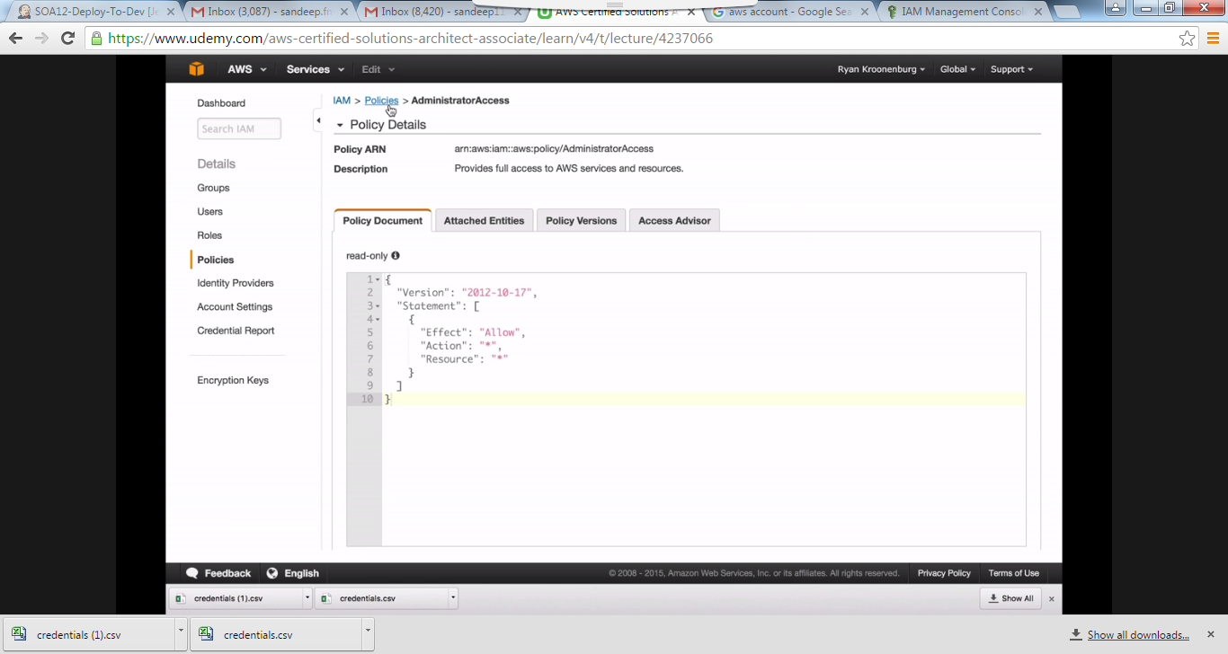

**Role:**

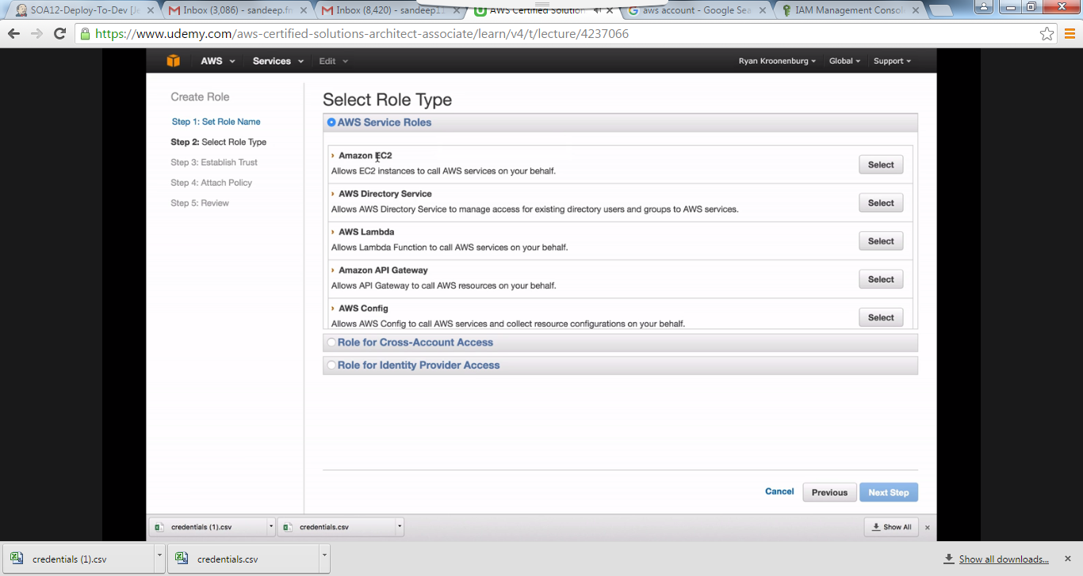

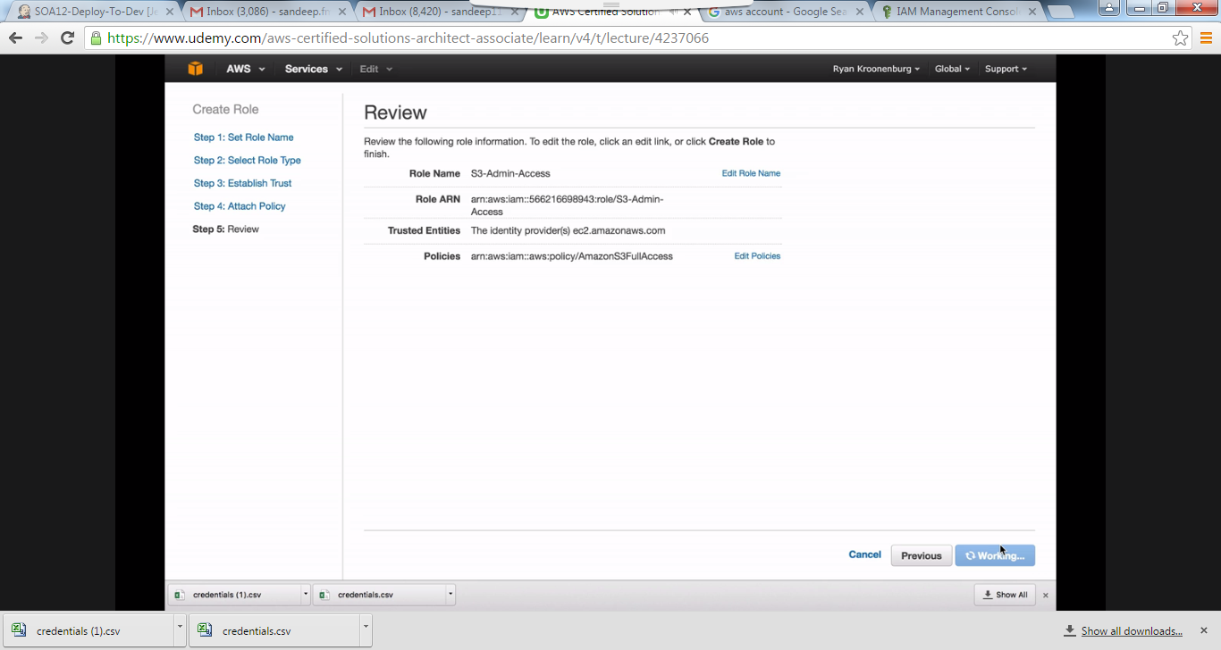

**Video14:** Policy documents are universal. They can be applied on Users, groups and Roles.

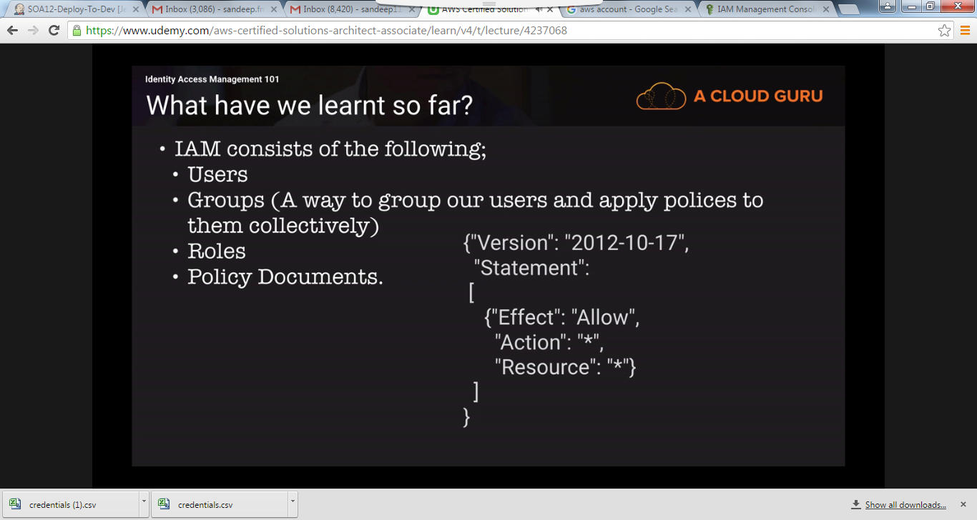

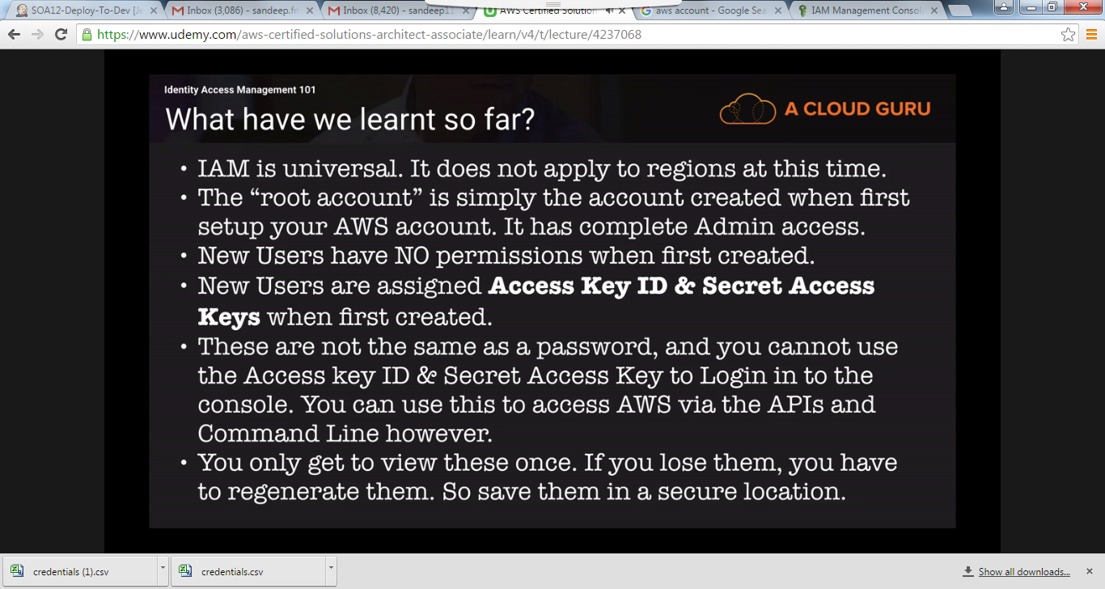

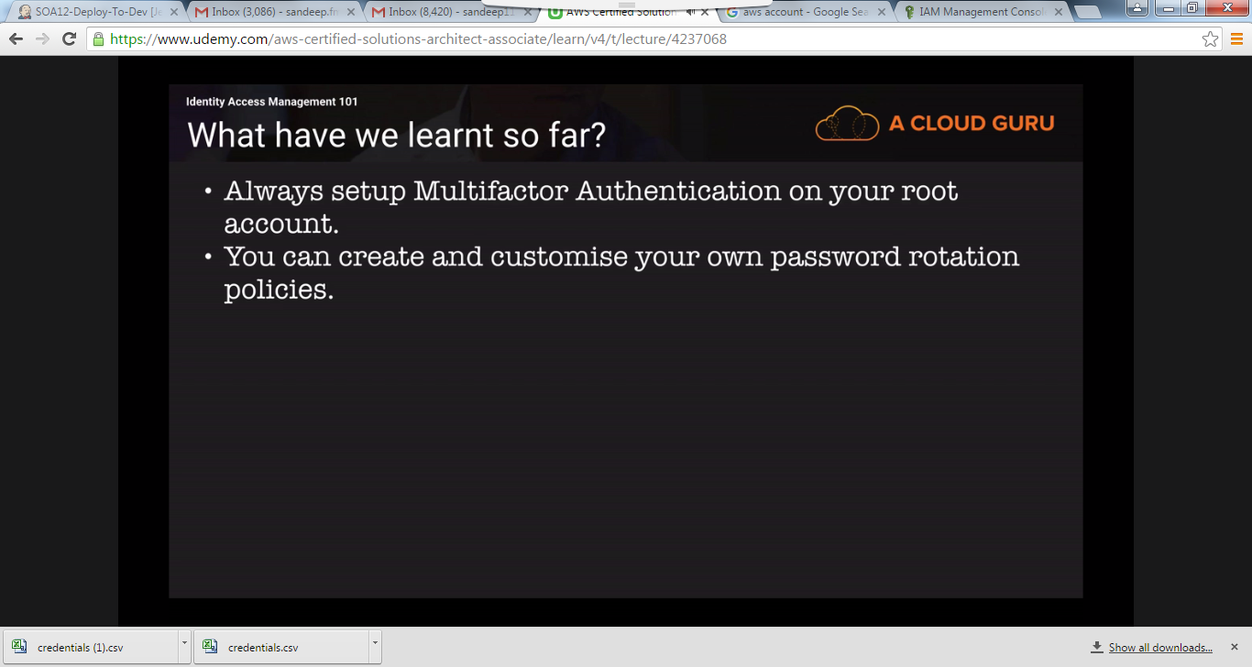

**Video15:**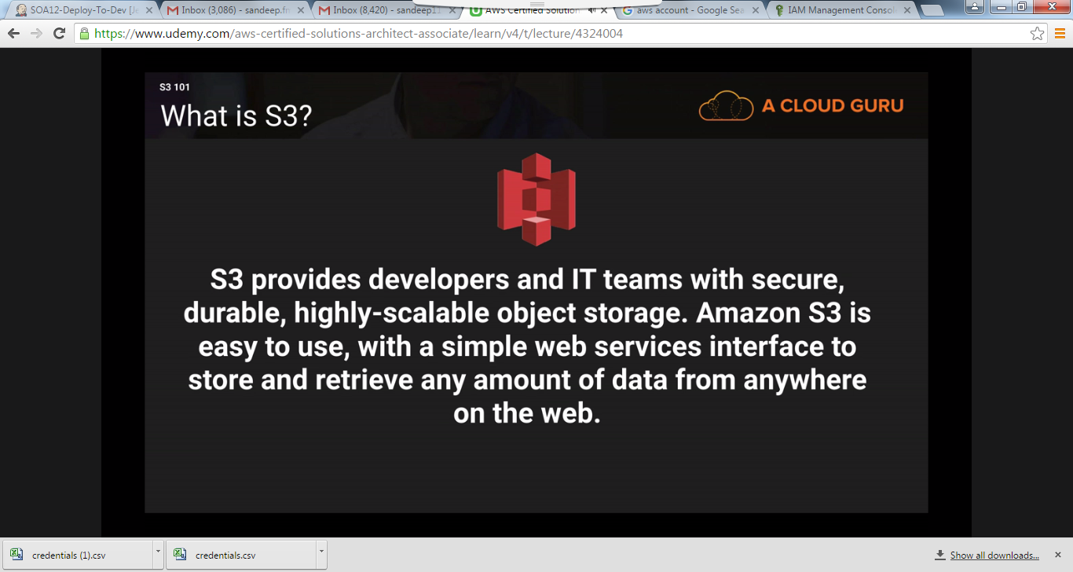

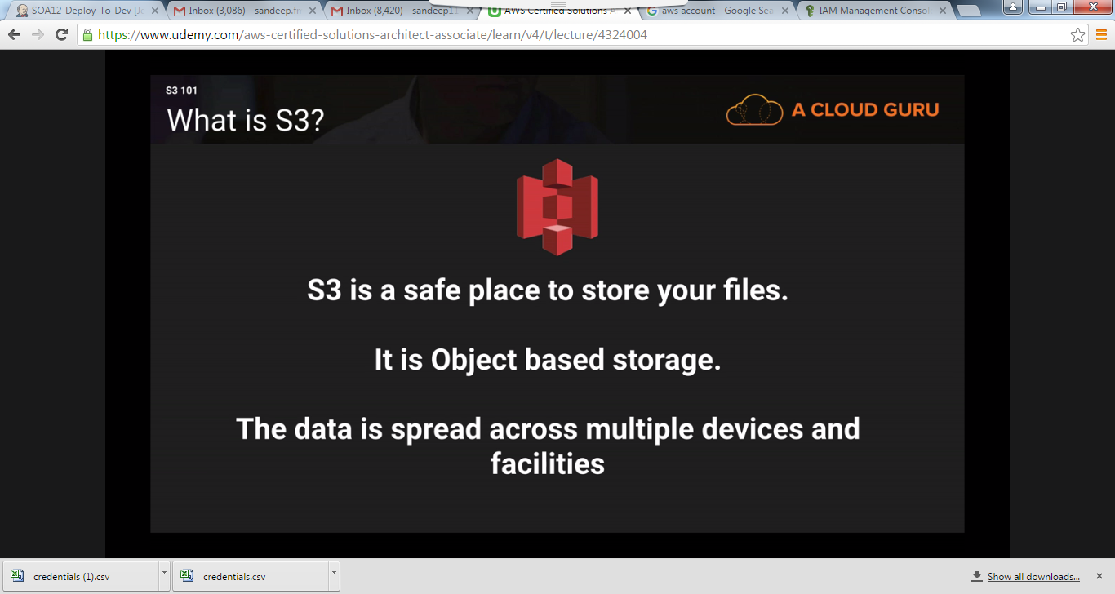Bucket is like a directory.

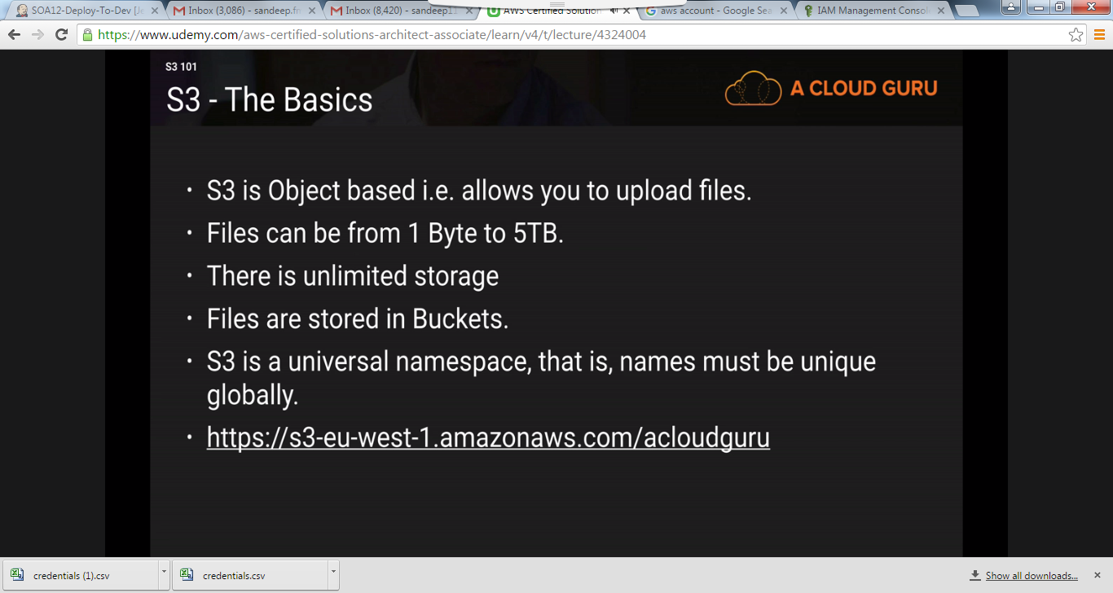

You can read the new objects as soon as you upload them but if edit or deletes an object then it will some time to reflect.

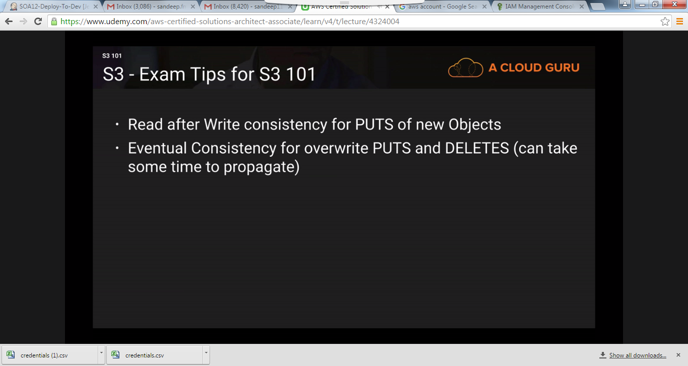

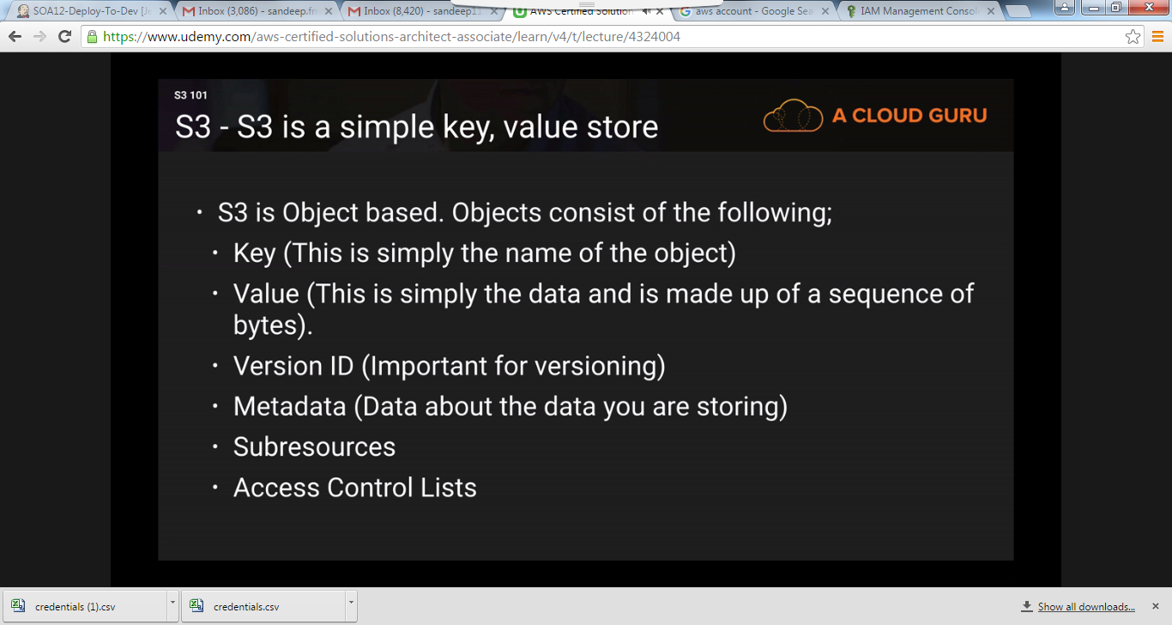Durability means if you are uploading 100 billion files then there is a chance that 99.99999999999 files will be uploaded and the remaining may not be.

